Project: Continuing from Part 1 project-based exam (Survey Form). Include a database of your choice so that when the save button is pressed, the data will transfer to a table. Also, please add an image of your choice on the form.

**Please record the project and copy and paste the URL below here. The recording must show the image, and the data transfer to the table.**

<https://www.loom.com/share/142bd1f8b47445838ea7d726471702af>

**Rubrics**

|  |  |
| --- | --- |
| Added an image | 25% |
| Database/Table connection | 25% |
| URL to recording | 25% |
| Zipped Application | 25% |
| Total | 100% |

Print screen proof that the data has been transferred to the table below here.



Print and screen the form with the image below here.

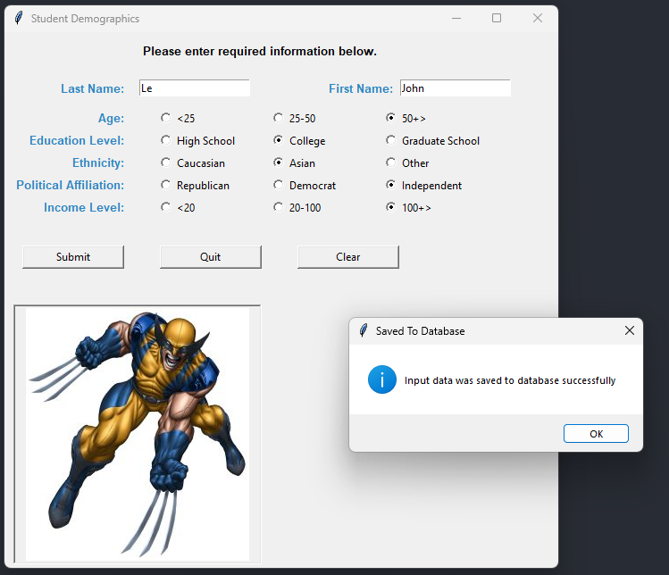

Print screen the code below here.

Code:

import tkinter as tk

import sqlite3 as sql

from tkinter import messagebox

from tkinter import PhotoImage

from datetime import datetime

def submit_form():

last_name = txtln.get()

first_name = txtfn.get()

age_val = age_var.get()

education_val = education_var.get()

ethnicity_val = ethnicity_var.get()

party_val = party_var.get()

income_val = str(income_var.get())

if age_val == 1:

age_range = "1 to 24"

elif age_val == 2:

age_range = "25-50"

else:

age_range = "50+"

if education_val == 1:

education = "High School"

elif education_val == 2:

education = "College"

else:

education = "Graduate School"

if ethnicity_val == 1:

ethnicity = "Caucasian"

elif ethnicity_val == 2:

ethnicity = "Asian"

else:

ethnicity = "Other"

if party_val == 1:

party = "Republican"

elif party_val == 2:

party = "Democrat"

else:

party = "Independent"

if income_val == 1:

income_range = "0-20K"

elif income_val == 2:

income_range = "20K-100K"

else:

income_range = "100K+"

def has_numbers(inputString):

return any(char.isdigit() for char in inputString)

def save_to_file(content):

try:

with open("C:\\Users\\17147\\Desktop\\CMPR114\\m8\\demographics.txt", "a") as file:

file.write(content)

file.close

except Exception as e:

messagebox.showerror(title="Missing Location", message="Please specify file location.")

def save_to_db():

try:

#open connection

conn = sql.connect("C:\\Users\\17147\\Desktop\\SQLLite\\PythonClassDB.db")

crs = conn.cursor()

crs.execute("INSERT INTO demographics (lastname, firstname, agegroup, educationgroup, ethnicitygroup, politicalgroup, incomegroup, createdt) \

VALUES(?,?,?,?,?,?,?,?)", (last_name, first_name, age_val, education_val, ethnicity_val, party_val, income_val, datetime.now()))

conn.commit() #Commit transaction

conn.close() #Close connection

return True

except sql.Error as e:

messagebox.showerror(title="Error", message=f"Database Error: {e}")

return False

if has_numbers(last_name) or has_numbers(first_name):

messagebox.showerror(title="Input Error", message="Please enter valid first and last name")

else:

content = (f"""Timestamp: {datetime.now()} \nName: {first_name} {last_name}\nAge Range: {age_range}\nEducation Level: {education} \nEthnicity: {ethnicity} \nPolitical Affiliation: {party} \nIncome Level: {income_range}\n""")

print(content)

save_to_file(content)

if save_to_db():

messagebox.showinfo(title="Saved To Database", message="Input data was saved to database successfully")

txtln.delete(0, tk.END)

txtfn.delete(0, tk.END)

txtln.focus_set()

def quit():

win.quit()

win.destroy()

def cleartext():

txtfn.delete(0, tk.END)

txtln.delete(0, tk.END)

rbLT25.select()

rb25To50.deselect()

rbGT50.deselect()

rbCaucasian.select()

rbAsian.deselect()

rbOther.deselect()

rbRepublican.select()

rbDemocrat.deselect()

rbIndependent.deselect()

rbHS.select()

rbCollege.deselect()

rbGraduate.deselect()

rbLT20.select()

rb20To100.deselect()

rbGT100.deselect()

txtln.focus_set()

#Set up window form

win = tk.Tk()

win.title('Student Demographics')

win.geometry("620x600")

#Instructions

lblInstruction = tk.Label(win, text = "Please enter required information below.", font="Arial 10 bold", anchor="e", fg="black")

lblInstruction.grid(row=0, column=0, ipadx=3, ipady=10, columnspan=5) #Label widge

#First and Last Name

lblln = tk.Label(win, text = "Last Name: ", font="Arial 10 bold", anchor="e", fg="#2E86C1")

lblln.grid(row=1, column=0, padx=10, pady=10, sticky="e") #Label widge

ln = tk.StringVar() #Manage the Entry widget

txtln = tk.Entry(win, width=20, textvariable=ln)

txtln.grid(row=1, column=1, ipadx = 0, padx = 0, pady=10, sticky="w")

lblfn = tk.Label(win, text = "First Name: ", font="Arial 10 bold", width=20, anchor="e", fg="#2E86C1")

lblfn.grid(row=1, column=2, padx=1, pady=10, sticky="e")

fn = tk.StringVar() #Manage the Entry widget

txtfn = tk.Entry(win, width=20, textvariable=fn)

txtfn.grid(row=1, column=3, ipadx=0, padx=0, pady=10, sticky="w")

#Age Classification

lblAge = tk.Label(win, text = "Age: ", font="Arial 10 bold", anchor="e", fg="#2E86C1")

lblAge.grid(row=2, column=0, padx=10, sticky="e")

frm1 = tk.Frame(win)

frm1.grid(row=2, column=1, padx=0, pady=0, columnspan=5)

age_var= tk.IntVar(frm1)

rbLT25 = tk.Radiobutton(frm1, text="<25", value=1, width=14, variable=age_var, anchor="w")

rbLT25.grid(row=0, column=1, padx=0, pady=0)

rb25To50 = tk.Radiobutton(frm1, text="25-50", value=2, width=14, variable=age_var, anchor="w")

rb25To50.grid(row=0, column=2, padx=0, pady=0)

rbGT50 = tk.Radiobutton(frm1, text="50+>", value=3, width=14, variable=age_var, anchor="w")

rbGT50.grid(row=0, column=3, padx=0, pady=0)

#Education Classification

lblEducation = tk.Label(win, text = "Education Level: ", font="Arial 10 bold", anchor="e", fg="#2E86C1")

lblEducation.grid(row=3, column=0, padx=10, sticky="e")

frm2 = tk.Frame(win)

frm2.grid(row=3, column=1, padx=0, pady=0, columnspan=5)

education_var = tk.IntVar(frm2)

rbHS = tk.Radiobutton(frm2, text="High School", value=1, width=14, variable=education_var, anchor="w")

rbHS.grid(row=0, column=0, padx=0, pady=0)

rbCollege = tk.Radiobutton(frm2, text="College", value=2, width=14, variable=education_var, anchor="w")

rbCollege.grid(row=0, column=1, padx=0, pady=0)

rbGraduate = tk.Radiobutton(frm2, text="Graduate School", value=3, width=14, variable=education_var, anchor="w")

rbGraduate.grid(row=0, column=2, padx=0, pady=0)

#Ethnicity Classification

lblEthnicity = tk.Label(win, text = "Ethnicity: ", font="Arial 10 bold", anchor="e", fg="#2E86C1")

lblEthnicity.grid(row=4, column=0, padx=10, sticky="e")

frm3 = tk.Frame(win)

frm3.grid(row=4, column=1, padx=0, pady=0, columnspan=5)

ethnicity_var = tk.IntVar(frm3)

rbCaucasian = tk.Radiobutton(frm3, text="Caucasian", value=1, width=14, variable=ethnicity_var, anchor="w")

rbCaucasian.grid(row=0, column=0, padx=0, pady=0)

rbAsian = tk.Radiobutton(frm3, text="Asian", value=2, width=14, variable=ethnicity_var, anchor="w")

rbAsian.grid(row=0, column=1, padx=0, pady=0)

rbOther = tk.Radiobutton(frm3, text="Other", value=3, width=14, variable=ethnicity_var, anchor="w")

rbOther.grid(row=0, column=2, padx=0, pady=0)

#Political Classification

lblParty = tk.Label(win, text = "Political Affiliation: ", font="Arial 10 bold", anchor="e", fg="#2E86C1")

lblParty.grid(row=5, column=0, padx=10, sticky="e") #Label widge

frm4 = tk.Frame(win)

frm4.grid(row=5, column=1, padx=0, pady=0, columnspan=5)

party_var = tk.IntVar(frm4)

rbRepublican = tk.Radiobutton(frm4, text="Republican", value=1, width=14, variable=party_var, anchor="w")

rbRepublican.grid(row=0, column=0, padx=0, pady=0)

rbDemocrat = tk.Radiobutton(frm4, text="Democrat", value=2, width=14, variable=party_var, anchor="w")

rbDemocrat.grid(row=0, column=1, padx=0, pady=0)

rbIndependent = tk.Radiobutton(frm4, text="Independent", value=3, width=14, variable=party_var, anchor="w")

rbIndependent.grid(row=0, column=2, padx=0, pady=0)

#Income Classification

lblIncome = tk.Label(win, text = "Income Level: ", font="Arial 10 bold", anchor="e", fg="#2E86C1")

lblIncome.grid(row=6, column=0, padx=10, sticky="e")

frm5 = tk.Frame(win)

frm5.grid(row=6, column=1, padx=0, pady=0, columnspan=5)

income_var = tk.IntVar(frm5)

rbLT20 = tk.Radiobutton(frm5, text="<20", value=1, width=14, variable=income_var, anchor="w")

rbLT20.grid(row=0, column=0, padx=0, pady=0)

rb20To100 = tk.Radiobutton(frm5, text="20-100", value=2, width=14, variable=income_var, anchor="w")

rb20To100.grid(row=0, column=1, padx=0, pady=0)

rbGT100 = tk.Radiobutton(frm5, text="100+>", value=3, width=14, variable=income_var, anchor="w")

rbGT100.grid(row=0, column=2, padx=0, pady=0)

#Create buttons on windows form

frm6 = tk.Frame(win)

frm6.grid(row=7, column=0, padx = 0, pady=10, columnspan=5, sticky="w")

btnSubmit = tk.Button(frm6, text="Submit", command=submit_form, width=12)

btnSubmit.grid(row=0, column=1, ipadx=10, padx=20, pady=20)

btnQuit = tk.Button(frm6, text="Quit", command=quit, width=12)

btnQuit.grid(row=0, column=2, ipadx=10, padx=20, pady=20)

btnClear = tk.Button(frm6, text="Clear", command=cleartext, width=12)

btnClear.grid(row=0, column=3, ipadx=10, padx=20, pady=20)

frm7 = tk.Frame(win, relief="sunken", bd=2)

frm7.grid(row=8, column=0, padx = 10, pady=10, columnspan=5, sticky="w")

jpg = PhotoImage(file="C:\\Users\\17147\\Desktop\\CMPR114\\m8\\wolverine25.png")

lblImage = tk.Label(frm7, image=jpg)

lblImage.grid(row=0, column=0, padx=10)

win.mainloop()

Submit this document to Module 8.